Yuvak Vikas Shikshan Prasarak Mandal Pimpaldari's
Late Sow Sheshabai Sitaram Mundhe Arts College, Gangakhed



Profile
Department of Sociology

WEL-COME
TO

NAAC PEER TEAM

DEPARTMENT OF SOCIOLOGY

  Mahatma Phule | 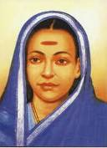  Savitribai Phule | 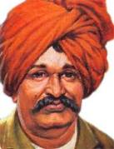  Rajshri Shahu Maharaj | 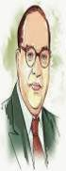  Dr.B.R. Ambedkar
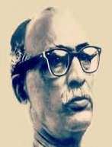  G.S. Ghurey | Social  Thinkers |  | 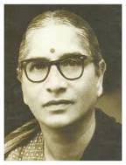  Iravati Karve
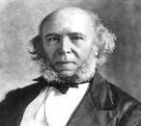  Herbert Spencer | 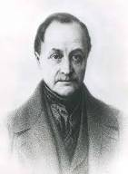  August Comte | 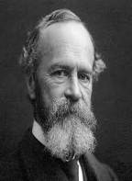  Emile Durkheim | 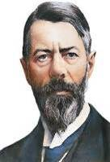  Max Weber

Introduction

The Sociology Department in Late Sow Sheshabai Sitaram Mundhe Arts College, Gangakhed has the same span of history as that of the mother institution. This subject is taught in our college senior level from the very beginning (1995).
Aims and Objectives
- To maintain the social and cultural values of Indian society.
- To provide higher education in sociology to rural and backward students.
- To compare Indian society with help of western sociological concept and theories.
- To develop indigenous social concept for scientific analyses of Indian society thought research.
- The develop link for the subject among the student.
- To develop social consciousness among the student.
- To prepare students for competitive exam.
- To know existing reality with the help of project work field tours and preparing reports of social reality.
- To promote student to under taken research work which is useful to the society.
Course Offered : B.A. (Sociology) 3 year
Semester | Paper No. | Title of the Paper
Sem. I | I | Introduction to Sociology
Sem. I | II | New Change in social Institution.
Sem. II | III | Basic Concept in sociology
Sem. II | IV | Contemporary Social institution
Sem. III | V | Indian society structure and change
Sem. III | VI | Human Rights and Social Justice
Sem. IV | VII | Issues & Problems in Indian Society
Sem. IV | VIII | Neo Sociological Movements
Sem. V | IX | Classical Sociological Thinkers
Sem. V | X | Methods of Social Research
Sem. VI | XII | Indian social thinkers
Sem. VI | XIII | Techniques of social Research
Faculty Position
Name | Qualification | Experience
1) Mr. N.K. Latpate | M.A.NET, SET (Ph.D.) | 20 (UG)
Students Strength
REACCREDITATION (2016-2021)
Year | B.A.F.Y. |  |  | B.A.S.Y. |  |  | B.A.T.Y.
Year | Boys | Girls | Total | Boys | Girls | Total | Boys | Girls | Total
2016-2017 | 38 | 27 | 65 | 06 | 17 | 23 | 06 | 01 | 07
2017-2018 | 35 | 22 | 57 | 20 | 24 | 44 | 07 | 15 | 22
2018-2019 | 30 | 26 | 56 | 20 | 15 | 35 | 13 | 16 | 29

Topper: B.A. Third Year
2016-2017
1 | Shelke Suryakant Vishvanath | 192
2 | Holambe Rajedra Ramesh | 190
3 | Bhosale Dnyaneshwar Devidas | 186
2017-18
1 | Shisode Kanchan Vitthal | 209
2 | Shisode Surekha Mansing | 209
3 | Mitkari Supriya Vaijanath | 205
2018-19
1 | Phad Swati Lahu | 252
2 | Bhalerao Gunabai Tulshiram | 239
2019-20
1 | Gore Aniket Shivaji | 231
2 | Padampalle Govind Bappaji | 229
2020-21
1 | Rathod Swati Balasaheb | 256
2 | Salve Sanjana Sanjay | 248

Contribution in the College and University
Latpate N. K. 2012-2017
College Level | SRTM University Level
- Worked as Member of Admission Committees.  - Worked as Member of N.S.S Committee  - Worked as comp.Exam and carrier gudince comp  - cosdodian | - Worked as paper seating U.G. level S.R.T.U.N.  - Worked as examiner U.G. level  - Participation in workshop seminar  - Framine syllabus sociology S.R.T.U Nanded  - Life Member of Marathi Samajshastra Parishad

Research Contribution
Latpate N. K.
Workshop / Seminar / Conferences Attended / Paper Presented
Particular | International | National | State | Total
Workshop | - | 02 | 01 | 03
Seminar | - | 04 | 02 | 06
Conferences | - | 1 | 02 | 03
Total | - | 05 | 05 | 12

Paper Presentation

Sr. No. | Title with page Nos. | Journal | ISSN/  ISBN No. | Whether peer reviewed. Impact Factor, if any | No. of co-authors | Whether you are the main author | Remark
1 | Jagtiki Karan Ani Bhartia Sheti |  |  |  | ----- | Yes

Conferences, Seminars, Workshops, Symposia
Sr.  No. | Theme of Conference / Seminar | Organized by |  |  | Level of the Conference/Seminar etc. | Date
INTERNATIONAL
1
NATIONAL
1 | Black Money | Digambarra Bindu College,  Bhokar |  |  | National  Seminar | 6th October, 2012
1 | Kaala Paisa aani Bharat
2 | Daridrya Nirmulan | Rameshrao Warpudkar Mahavidyalaya,  Sonpeth |  |  | National  Seminar | 28-29 March, 2014
2 | Daridrya Nirmulan Ek Avhan
3 | Jagatikikaran |  | PAH College, Ranisawargaon |  | National | 23 March, 2019
3 | Jagtikikarnache Bhartia Shetivaril Dushparinam
UNIVERSITY LEVEL
1 | Workshop on New Syllabus |  | Sharda College, Parbhani |  | University Level | 10th August, 2010
2 | Workshop on New Syllabus |  | Mahatma Phule College,  Ahmedpur |  | University Level
3 | Rashtria Jal Shinchan Parishad |  | Shankarrao CHavan Mahavidyalaya,  Ardhapur |  | National | 26th February,.  2019

Alumine
ekthfo|kFkhZ ;knh
v-dz | fo|kF;kZpsuko | “kS{k.khdo’kZ | l/;k dk;Zjr
1 | VksdyokM jktkjke f”kokth | 2004-05 | Loa;jkstxkj
2 | Fxrr slq;Zdkar izdk”k | 2006-07 | [kktxh {ks=krdk;Zjr
3 | QM ek;kHkoku | 2012-13 | odhy
4 | Lkriqrsehjk =acd | 2004-05 | xzg.kh
5 | Ekksjsf”kry “kadj | 2004-05 | xzg.kh
6 | eqa<s lathoucGhjke | 2008-09 | oufyfid ]panziwj
7 | Hkkslysioulq/kkdj | 2013-14 | Loa;jkstxkj
8 | QM Lorhnsfonkl | 2014-15 | Dsanzh; jk[khoiksyhl
9 | vkoGsfo”oukFkcGhjke | 2015-16 | Hkkjrh; y’dj
10 | [kkaMsKkus”ojizHkw | 2015-16 | Dsanzh; jk[khoiksyhl
11 | Dkax.kscGhjkejkejko | 2015-16 | Dsanzh; jk[khoiksyhl
12 | Iqkjhxtkuu fo’.kw | 2015-16 | Dsanzh; jk[khoiksyhl
Activities
Curricular Activities
The Department at Sociology with its scholarly facility is engrossed in the pervasive prosacity of the student at UG various curricular activities of the department are as follows
- Unit Test
- Tutorials
- Term Exam
Curricluar Activities
- Seminars
- Group Discussion
- Guest Lecture
- Wall Paper

Photo Gallery
Photo Gallery:-

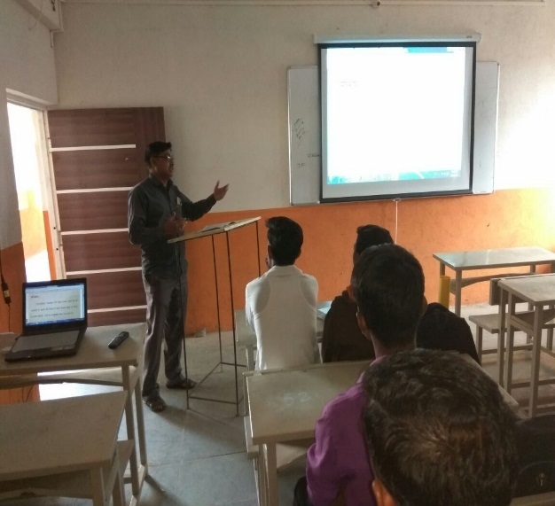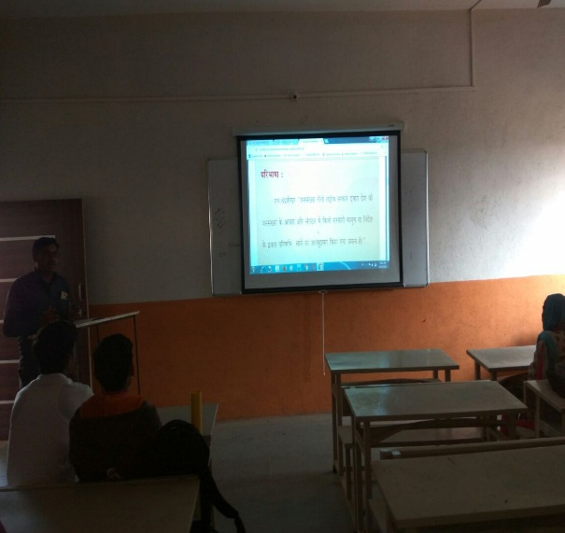

Language Lab Activity: Use of PPT and Projector 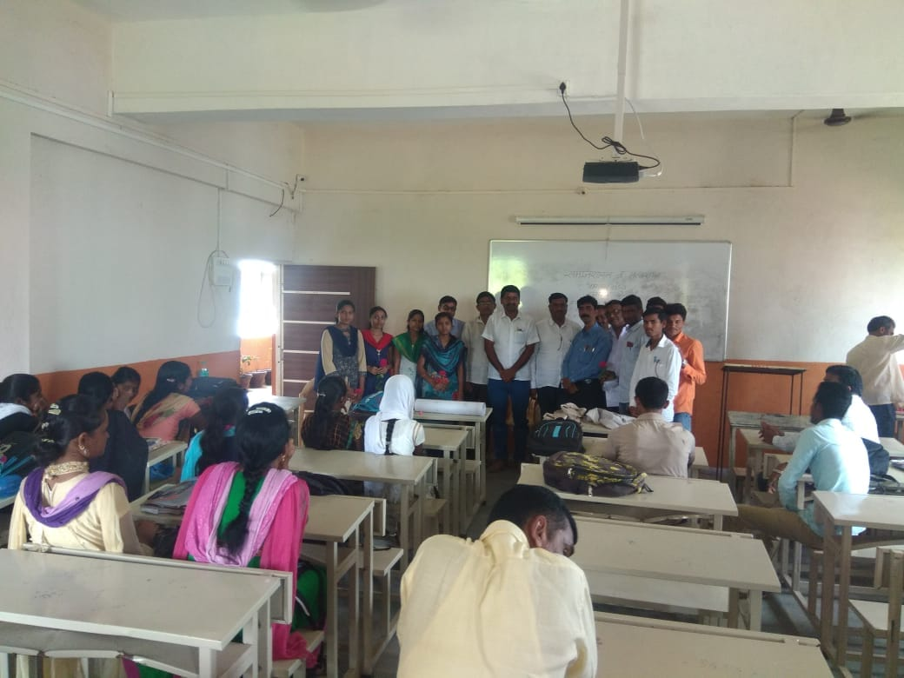
Guest Lecture

