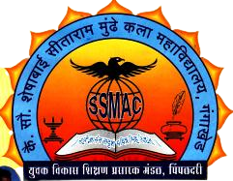**Swami Ramanand Teerth Marathwada University, Nanded Affiliated**

Yuvak Vikas Shikshan Prasarak Mandal’s

**Late Sow Sheshabai Sitaram Mundhe Arts College,**

**Gangakhed Dist. Parbhani- 431514 (M.S.)**

College Code: 225

Establishment: 1995

UGC Recognized 2(f) & 12(b) status

**Department of Sociology**

Principal Head of the Department

Dr B. N. Dhakne Contact No.: 9421381754 Mr. N.K. Latpate

M.Sc.,M.Lib.,M.Phil.,Ph.D. M.A.,NET, SET.

Email: [ssmac.gkd@gmail.com](mailto:ssmac.gkd@gmail.com) Email: [namdevlatpate557@gmail.com](mailto:namdevlatpate557@gmail.com)

**Photo Gallery**

Use of ICT

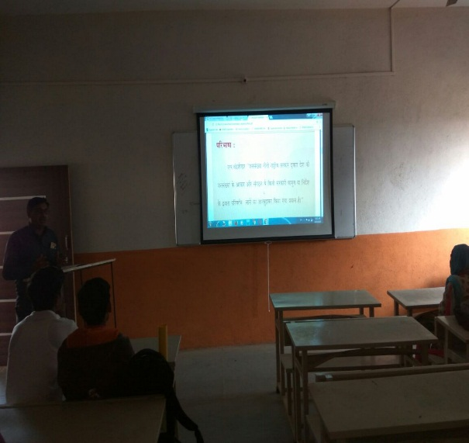

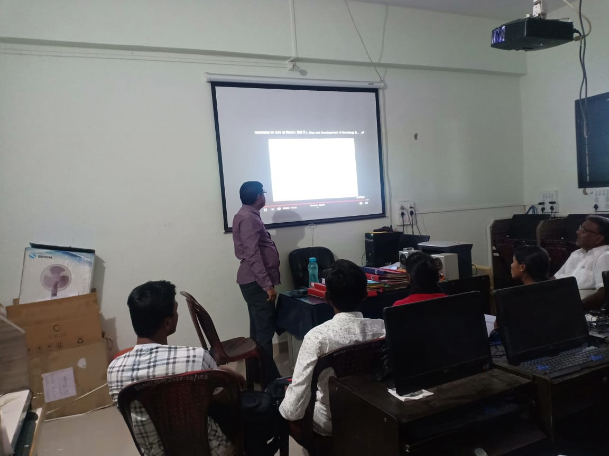

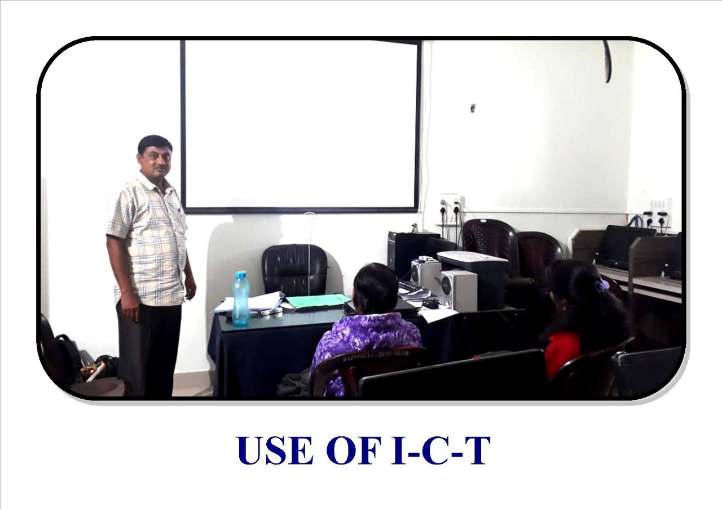

Guest Lecture

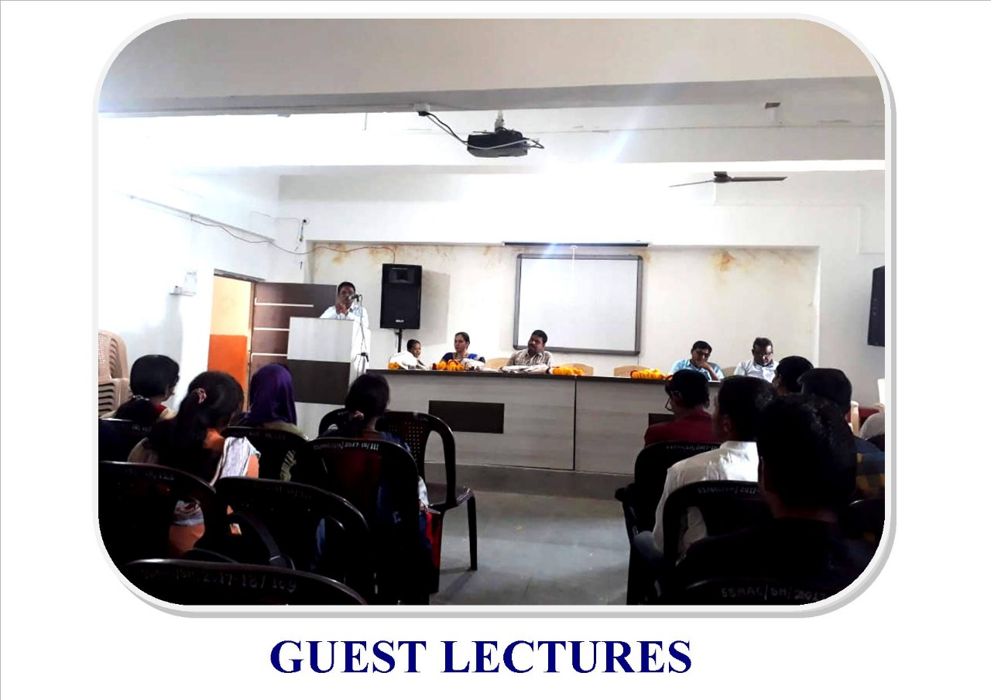

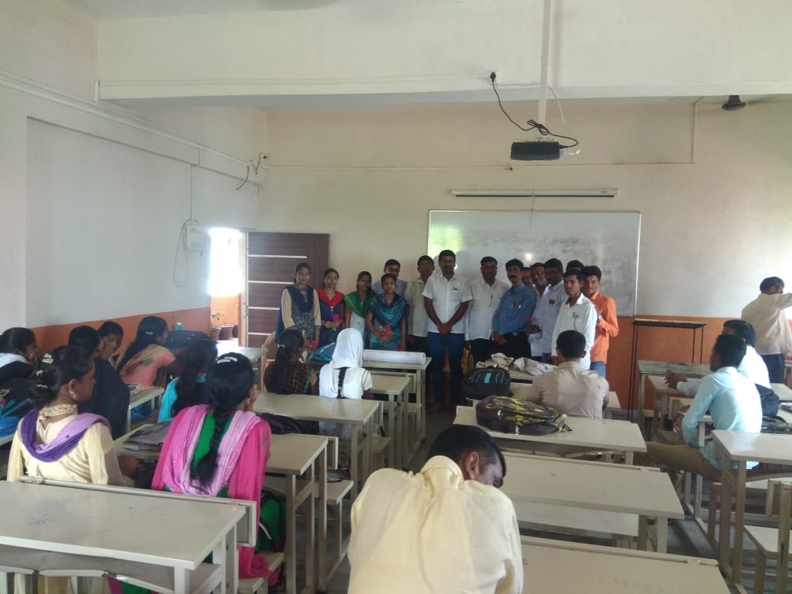

Wall Paper Publication